Looking for new directions for research? This session is for you!

How Can Careers Theory and Research Expand Our Understanding
of the Aging Workforce ?
Monday, Aug 13 2018 7:30AM - 11:00AM at Hyatt Regency Chicago in Plaza A
Academy of Management Conference, Chicago

Co-Chairs: Robert Ford and Sherry E. Sullivan
Moderator: Ariane Froidevaux, University of Florida
Speakers and Topic Areas:
Monica C. Higgins, Harvard, “Accessing Multiple Networks for Career Mentoring: Senior Scholars as a Developmental Resource”
Jos Akkermans, Vrije Universiteit, “How Career Competencies Change Across a Work Life: Are Older Workers Different?”
Tania Casado Universidade de São Paulo, “Do Values Change Across a Career: Are Older Workers More or Less Ethical than New Entrants?”
Michael Arthur, Suffolk University, “Is Age a Boundary in a Boundaryless Career?”
Corinne Post, Lehigh University, “Does Age Make a Difference in Work-Life Conflict?"

Each of the five distinguished speakers will briefly discuss (10 minutes/speaker) how his/her past research can spur future research into exploring the influence of that body of work on aging or senior employees. Then, members of the audience will choose a roundtable to join based on their interests. Each table will be led by one of the speakers and will allow discussion of that speaker’s ideas in greater depth. The emphasis of this session will be on helping junior faculty and doctoral students to identify new ideas for their research and to obtain some mentoring guidance on how to proceed from the distinguished speakers. (7:45 - 8:15 CASS Welcome Breakfast prior to start of session)
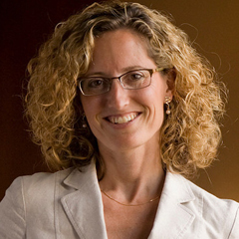
Monica Higgins is the Kathleen McCartney Professor of Education Leadership at the Harvard Graduate School of Education (HGSE) where her research and teaching focus on the areas of leadership development and organizational change. Her book, Career Imprints: Creating Leaders Across an Industry, (2005) focuses on the leadership development of executives in the biotechnology industry. She has written extensively on mentoring and networks, publishing in journals including the Academy of Management Review, Strategic Management Journal, Harvard Business Review, Journal of Organizational Behavior and Journal of Vocational Behavior.

Jos Akkermans is Associate Professor of Sustainable Careers and Organizational Behavior at the School of Business and Economics of VU Amsterdam. He is a leading researcher on projects related to sustainable career development, changing employer-employee relationships, and young workers. Jos is associate editor for the Journal of Vocational Behavior, an editorial board member for Career Development International, and a member of the AOM Careers Division executive team. He has published in leading journals in the fields of careers, OB, and HRM, including Journal of Vocational Behavior, Human Resource Management, Applied Psychology, and European Journal of Work and Organizational Psychology.
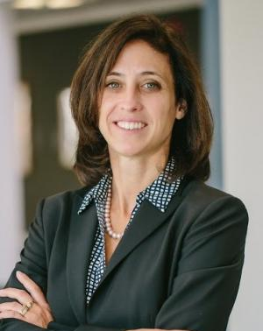
Corinne Post holds the Scott Hartz Professorship at Lehigh University. Her research interests center on gender and racial differences in individual work experiences and career trajectories, as well as on the effects of diversity on innovation and performance, including boards of directors. Her publications have appeared in such journals as Academy of Management Journal, Academy of Management Review, Administrative Science Quarterly, Journal of Applied Psychology, Journal of Business Ethics, and Human Relations. She is past Chair for the Careers Division of the Academy of Management. She is Associate Editor, Journal of Management Studies and on the Editorial Review Boards of Journal of Business Ethics and Career Development International.

Tania Casado is a professor and director of the Office of Careers Services and School of Economics, Administration and Accounting (FEA) at the University of São Paulo. She is a well published scholar who writes extensively on careers and ethics. Tania is a former chair of the Academy of Management’s Career Division.

Michael B Arthur is a thought leader in career studies, and originator of the term The Boundaryless Career. He was the 2006 recipient of the Academy of Management Everett C. Hughes Award for lifetime achievement in Career Studies, and is a co-developer of the Intelligent Career Card Sort® (ICCS®) career exploration instrument. He was recently appointed as a contributor to Forbes.com, and charged to write about career ownership. His most recent book (with Svetlana Khapova and Julia Richardson) is titled An Intelligent Career: Taking Ownership of Your Work and Your Life, published by Oxford University Press, which seeks to promote the authors' ideas directly to potential users (including students).
Ariane Froidevaux is currently a postdoctoral researcher at the Department of Management of the Warrington College of Business at the University of Florida. She was awarded the Early and Advanced Postdoc.Mobility Fellowships by the Swiss National Science Foundation. Her research focuses on late careers and retirement that explores three areas: (1) identity threat and negotiation, (2) career transitions and adjustment, and (3) bridge employment. She is a rspresentative at large for the Academy of Management’s Career Division.

Sherry E. Sullivan (Ph.D., The Ohio State University) is the co-developer of the Kaleidoscope Career Model and conducts research on careers, networking, mentors, expatriates, and international human resource management. Her research has been published in journals including the Journal of Management, Journal of International Business Studies, and Career Development International. She is a Fellow of Southern Management Association, a former Chair of the Careers Division, and currently serves as the Careers Division’s historian.

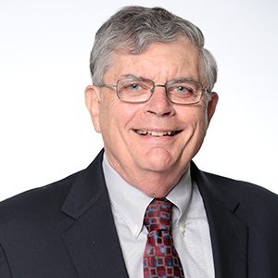
Robert C. Ford (PhD, Arizona State University) is professor emeritus of management at the University of Central Florida where his focus has been on managing service organizations. He has authored or coauthored nearly 100 publications in both top research journals such as the Academy of Management Journal and Journal of Applied Psychology and leading practitioner journals such as the Academy of Management Executive, California Management Review, Business Horizons, and Organizational Dynamics. Bob has held every elected office in Southern Management Association (SMA), including president. He is a SMA Fellow and was awarded the “Richard M. Hodgetts Distinguished Career Award,” by the Management History Division of the Academy of Management. Bob has served the Academy of Management as editor of The Academy of Management Executive, Chair of both the Management History and the Management Education and Development Divisions, Chair of Placement, Chair of the Ethics Adjudication Committee, Board member of the Human Resource Management Division, and co-founder of the Community of Academy Senior Scholars.

This session is sponsored by Community of Academy Senior Scholars (CASS) and The Careers Division.
Please contact Bob Ford for more information at: rford@bus.ucf.edu
